**Future Academy**

**Higher Future Institute For**

**Specialized Technological Studies**

**SOFTWARE ENGINEERING**

**BM LIBRARY APP**

**Dr. Heba M. El-Hoseny**

* **Team Members:**

|  |  |  |
| --- | --- | --- |
| **1** | **Michael Raafat Mafdy** | **220180085** |
| **2** | **Mohammed Yehia Mohammed** | **220180127** |
| **3** | **Mohamed Osama Mohamed** | **220180185** |
| **4** | **Ahmed Nasser Hamdy** | **220180462** |
| **5** | **Mostafa Khaled Mostafa** | **220180145** |
| **6** | **Bassam Khaled Ahmed** | **220180413** |
| **7** | **Mohammed Ehab Mohammed** | **220180275** |

* **Project Main Goals :-**

**Facilitate and Increase Knowledge and publish books and films that aim to spread cultures, science and technology and help peoples in scientific research and collect information for all people and students.**

* **Project Objectives :-**
* **Provides the searching facilities based on various factors. Such as Movie or book type , Director , Address and Authors.**
* **Manage the information of books and movies.**
* **Increase Knowledge and publish books and films that aim to spread cultures.**
* **help peoples in scientific research and collect information.**
* **Reference of movies and books.**
* **To reduce the use of papers and the loss of books.**
* **Project Requirements :-**
* **Functional Requirements:**

it's an android App (Flutter Platform).

Showing type, director, address and authors of book or movie.

User manages the information of books and movies to help him to increase knowledge and publish books & movies that aims to cultures and helps them in scientific research and collecting information.

* **Non-Functional Requirements:**

The user will find it very easy to use, it has a unique UI (User Interface), the user will have a great Experience so we hope he use our app again, it's very secure about customers information, and it has a unique performance.

* **Used Technology**

**Mobile Development: Flutter and Dart**

**UI: Adobe XD**

**Database: Firebase Server**

* **Flowchart :**

**HOME FLOWCHART**

Open PDF

Viewer

Open Video Player

Open item Descriptionv

If Clicked on Items

Show Items

Load Category Item

open Category page

If Clicked on Categories

Show Menu Categories

Register Or Login

**USER FLOWCHART**

Yes

Open Video Player

Open Pdf Viewer

If Clicked on Book

Load Items

Search Bar

Sign Out

Favorites

Books

Movies

User Icon

Show Menu Categories

Yes

No

Yes

No

Home Screen

**If Confirmed**

If User Registered

login

Check Validation

Open sign in page

Enter password

Enter username

Enter email

Register

* **Site Map :-**

Dark Mode

SignOut

Pdf Viwer

Author Name

Address Item

Video Player

Director

Movie Name

Give Problem

MY Favorite

Name

Search Result

Home Screen

Login Screen

Search

Account Setting

Movie List

Book List

* 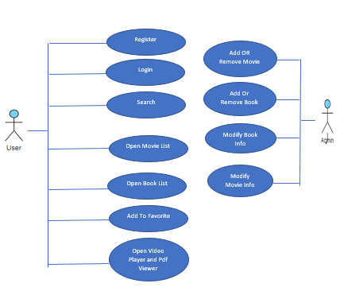**USE CASE:-**